Cuttlefish Bone Casting Barbara Mann bimann2@hotmail.com
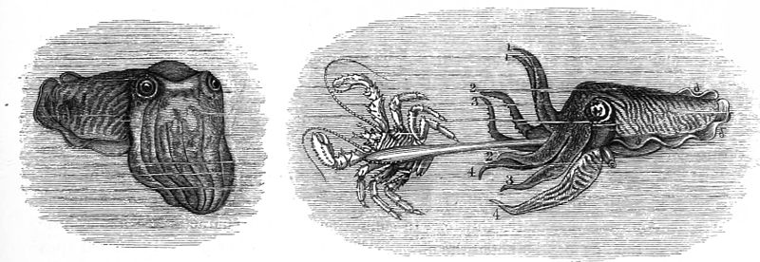
Cuttlefish are soft-bodied marine cephalopods, with a large head ringed by tentacles and an internal cuttlebone. Cuttlefish display natural camouflage, sepia ink squirting, jet propulsion and neutral buoyancy. Despite their name, cuttlefish are not fish; they are mollusks like an octopus.

Cuttlefish bones or cuttlebones are the internal calcareous or calcium-rich shell of the cuttlefish. They are white, chalky, surfboard-shaped shells that often wash up onto beaches. They are all that remains after a cuttlefish has been attacked and eaten.
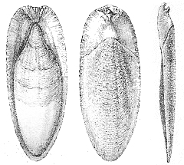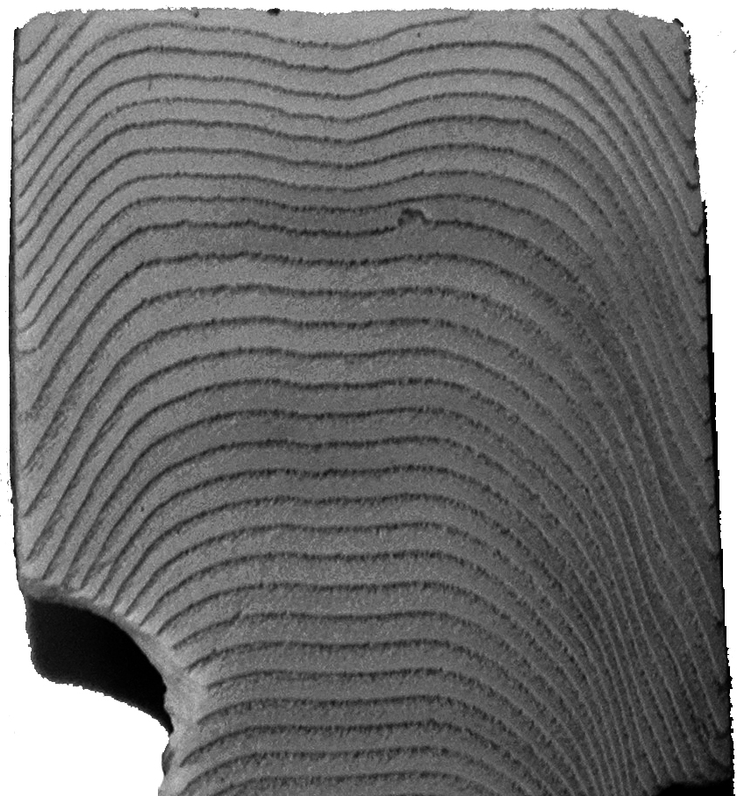
bottom top side texture texture cast in silver

The cuttlefish bone is made up of many layers of porous, calcareous shell interspersed with tiny, gas-filled cells. This allows the cuttlefish to vary the amount of fluid to air in the shell and have neutral buoyancy.
The cuttlefish bone also protects the internal organs and forms a framework against which the muscles can pull. Some cuttlebones that are washed up onto beaches have teeth marks on them. These marks usually occur during the death struggle but are sometimes inflicted after death by hungry birds and fish while the shell is still floating in the ocean. Studying the bite marks may give some idea of the type of marine life found in that area.
All cuttlefish are "amazing." They are intelligent and exhibit quite complex behaviour. They can change both the color and texture of their skin rapidly to provide natural camouflage. Cuttlefish glide through the water by gently rippling their skirt-like fins. They have neutral buoyancy and can vary their depth easily by changing the proportion of liquid to air in their internal skeleton, the cuttlefish bones. When threatened, a cuttlefish will squirt sepia ink into the water and hurry away using a form of jet propulsion.
Cuttlefish have the ability to change color very rapidly, making them extremely good at natural camouflage. They can change color in less than a second. They also use color to signal emotions such as anger, fear and sexual arousal. They will flush deep red when agitated and then change to a mottled sand colour as natural camouflage so they can disappear into their surroundings.
Chromatopores
Embedded in the skin of a cuttlefish are numerous elastic pigment sacs called chromatophores, which are surrounded by circular muscles. When the muscles contract, these sacs are stretched out into flat discs of dense pigment and when the muscles relax, the sacs fold down into small dots of color.
Chromatophores produce the orange to red, brown to black and yellow colors of the skin. Reflecting cells that provide the cuttlefish with blue and green coloration are called Iridophores; Leucophores form white spots.

Skin Texture
Cuttlefish can also change the texture of their skin for natural camouflage. By contracting certain muscles, the cuttlefish can sprout spiky-looking projections called papillae. They can use skin textural and color changes to disguise themselves as a patch of swaying kelp, a cluster of coral or even a chunk of rock.

Sepia Ink
If natural camouflage fails, the cuttlefish shoots ink out at the pursuer. The sepia ink may be produced as a mucus-bound blob or as a large cloud. It is secreted from a sac near the anus and discharged through the siphon. Sepia ink ejection is usually followed by a rapid color change to confuse the pursuer. Sepia ink was once widely used in printing, art and photography.

Anatomy
Cuttlefish are soft-bodied Mollusks with short, flattened bodies and a large head. Cuttlefish skin is soft delicate, and slides easily back and forth over an oval mantle of muscle that is attached to the rigid, internal cuttlefish bone. It is covered with Chromatophores or pigment sacs which allow the cuttlefish to change color for camouflage purposes, mating rituals and to show emotions.
Cuttlefish have eight sucker-lined tentacles that are attached to the head in a ring around the mouth. They also have skin flaps along each side which shield two retractable feeding tentacles that are longer than the rest and are flattened at the end.

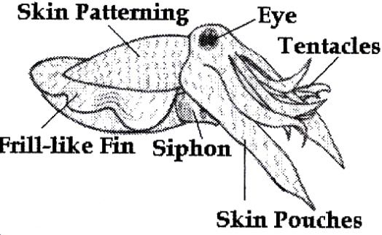
On the underbelly, there is a forward opening cavity that contains the gills and openings for the gut, kidneys and sexual organs. There is a siphon just beneath the head which helps the cuttlefish to steer and swim. Cuttlefish have large eyes with a W-shaped lens and, a transparent cover and lid. The body is edged by a thin frill-like fin which circles horizontally around the body.
Cuttlefish usually grow to between 5 and 30 centimeters long, but the giant cuttlefish grow much bigger. Giant cuttlefish are only found in the waters off southern Australia and they produce cuttlefish bones up to 1 meter long. Cuttlefish are only usually seen in large numbers near the shore in winter when they gather on the shallow reefs to mate and spawn.

Cuttlefish bones are a valuable source of calcium to a bird, when placed in bird cages. They can be ground into a fine powder that can be used for polishing silver or even, cleaning teeth. They are used by craft workers for sharpening fine instruments, and are used by silversmiths for making molds for casting.
